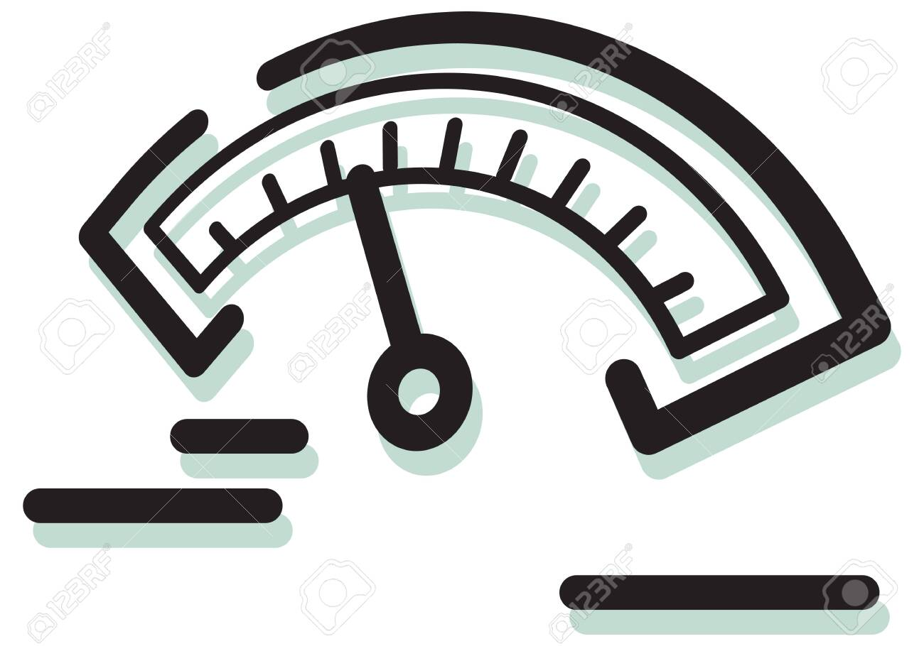

Pupper Servo Calibration guide

Eaaa’s Createlab

Version 1.0

16/02/2021